Set EnableNewBOB Firm Property

Overview

New requirement
SPX-Linage project changes the way how manual quotes of BOB class are handled. For roll-out purpose, a new property, called ‘EnableNewBOB’, is added in this project. When this property is turned on and set to true, manual quote of BOB class will be handled by new process; When this property is false or not set, manual quote of BOB class will be handled by existing process:
- This property must be available only at Session and Class level.
- The exchange and firm associating with this property have to be set to default value
- The session and class firm associating with this property can not be default value
- This property must be available for both OHS and TE
- This parameter must be intra-day configurable
- The Default value must be set to ‘False’

Design/Implementation

For this property to be accessed at both OHS and TE side, it has to be implemented as firm property. (Neither routing property or trading property can be accessed at both OHS and TE.)

Typically, a firm property can be set/accessed at either default level or individual firm level. However, based on requirement, the ‘EnableNewBOB’ property can only be set/accessed at default firm level. This requires us to do something different:
- Create a new key SessionDefaultFirmSimpleClassKey, which extends SessionFirmSimpleClassKey but only allow setting default firm rather than any individual firm. By doing so, GUI can build logic to handle this key differently from other SessionFirmSimpleClass firm properties, such as not allowing to set this property at individual firm level.
- Set firm property MASK as: ENALBE_NEW_BOB_MASK = {{0,1,1,0}}
The rest of changes with the EnableNewBOB firm property will be implemented following the standard framework of CBOE firm property. See figure 1 for the classes that will be updated or created for the new property.
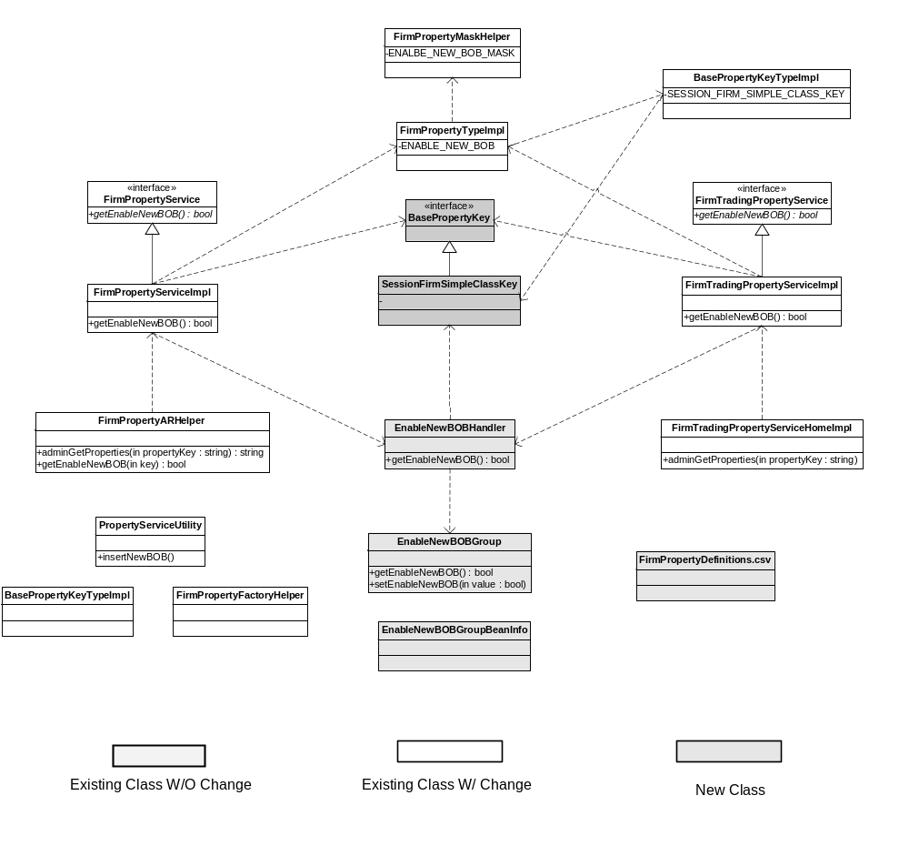
Figure 1. Java Classes for EnableNewBOB firm property

Scripts
- None

Database
- None

SetContext

XML/DTD

Classes/Property Files
- FirmPropertyMaskHelper.java
- FirmPropertyTypeImpl.java
- FirmPropertyFactoryHelper.java
- BasePropertyKeyTypeImpl.java
- EnableNewBOBGroup.java (New)
- EnableNewBOBHandler.java (New)
- FirmTradingPropertyService.java
- FirmTradingPropertyServiceImpl.java
- FirmTradingPropertyServiceHomeImpl.java
- FirmPropertyService.java
- FirmPropertyServiceImpl.java
- PropertyServiceUtility.java
- FirmPropertyARHelper.java
- FirmPropertyDefinations.csv

PerformanceTestingProcedure
- .

TestingProcedure

OperatorProcedure
- .

Fallback/Failover

